MS Teams: External User Guide

Guest access to your MS Team

Steps to assisting External/Guest users
These are the detailed steps involved in getting an External Users to access your MS Teams:

Step 1
Collaborative Solutions creates the guest user account.

Step 2
Team owner adds the guest user to their MS Team. Copy and paste their email address is the most effective way.

Step 3
The external user receives 2 emails after being added to an MS Team. A MS Teams invite email and a Group email (this Groups email can be ignored). In the Teams invite email, the user clicks on ‘Open Microsoft Teams’.
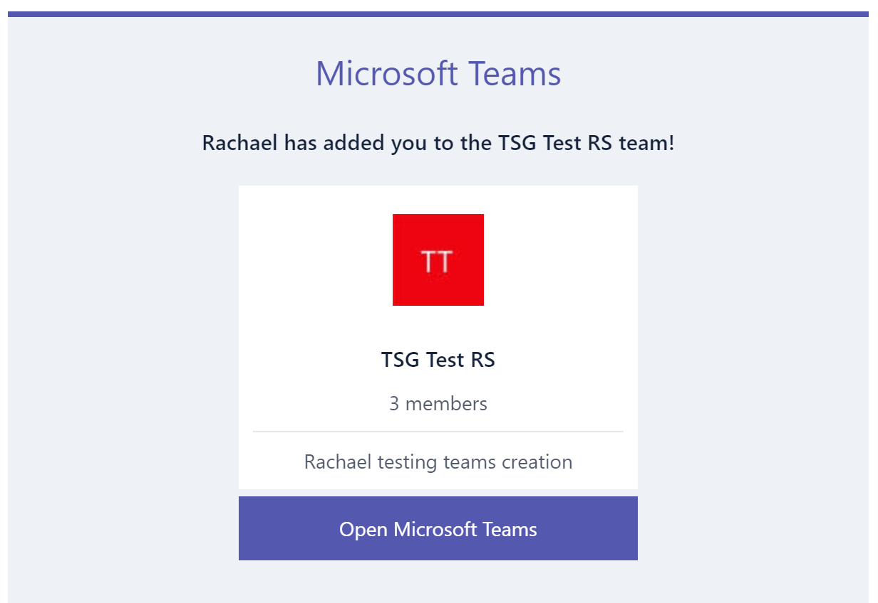

Step 4
If they have a desktop version of Teams app, this is the preferred experience, but the web version is fine for most things. If they click through, they will get this next screen:
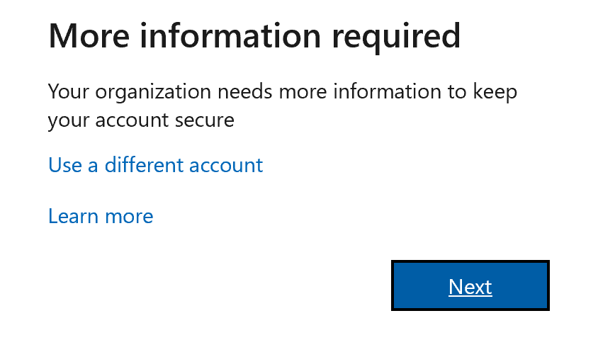

Step 5
Click ‘Next’ and the external user gets this screen where they can choose to use the ‘Authentication App’ or ‘I want to set up a different method’ for mobile Multi Factor Authentication.
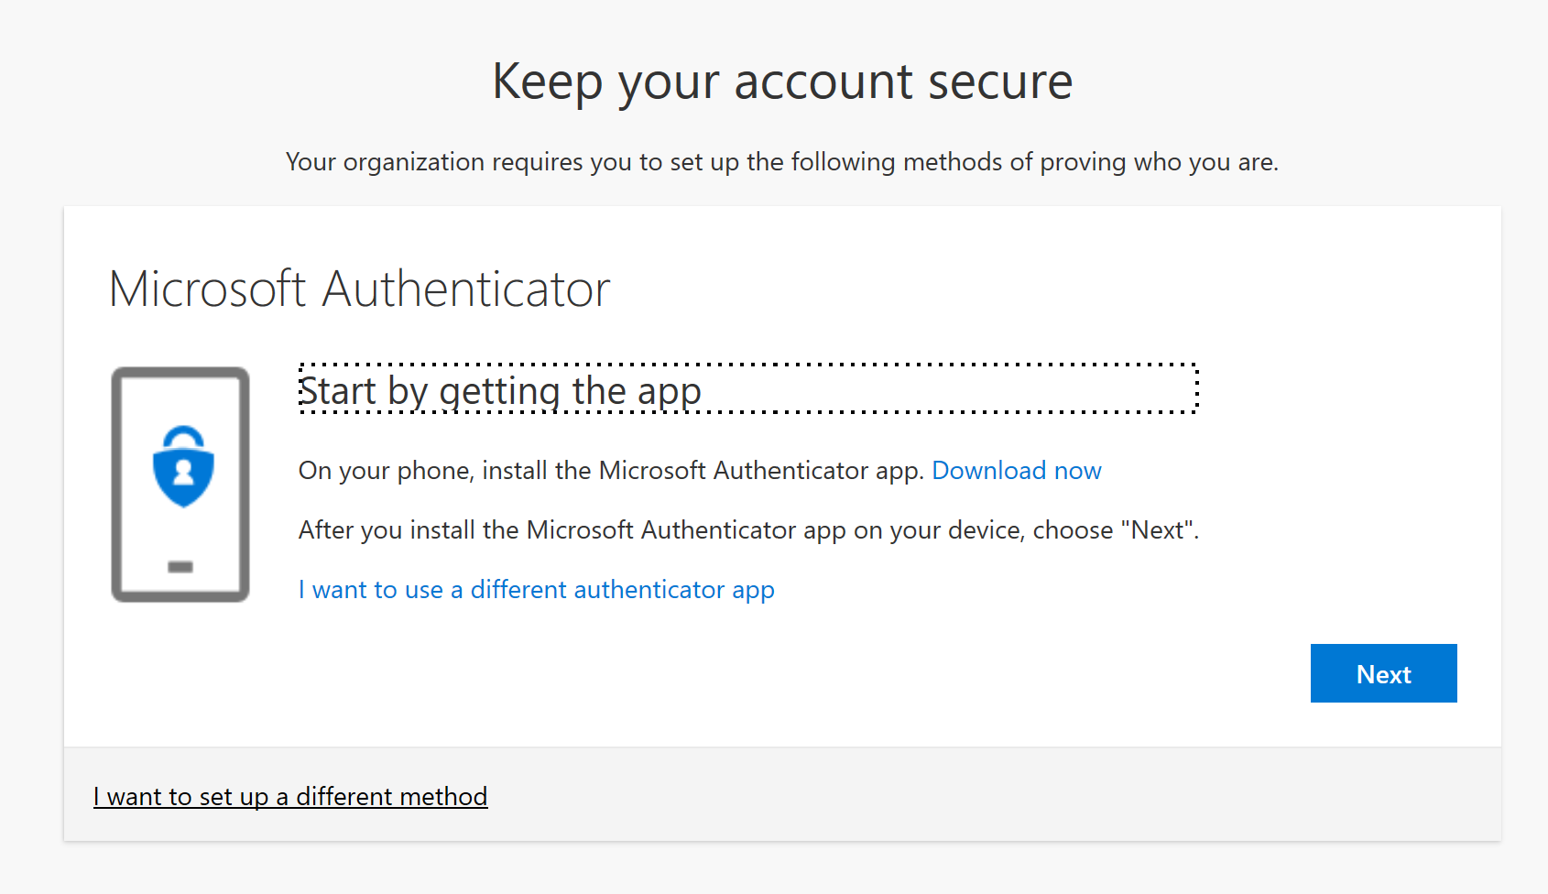

Mobile SMS Authentication

Step 1
If the external user selects the link at the bottom 'I want to set up a different method' then they get this screen:
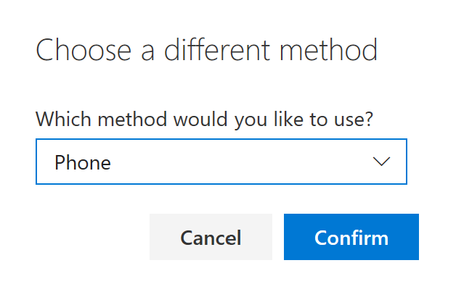

Step 2
Select ‘Confirm’ and they get:
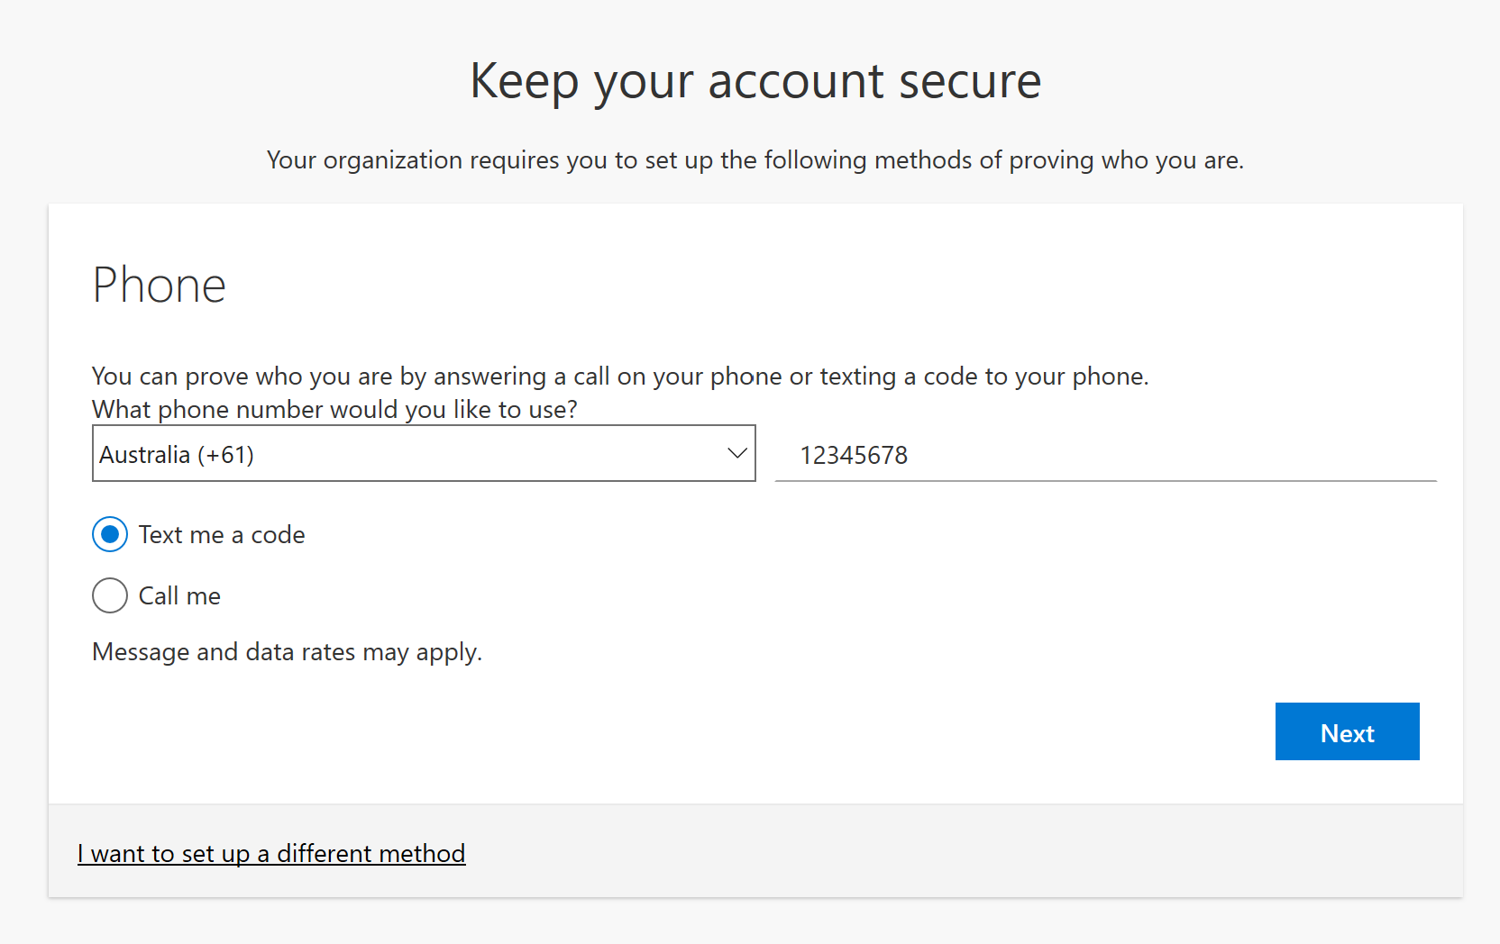

Step 3
Click ‘Next’:
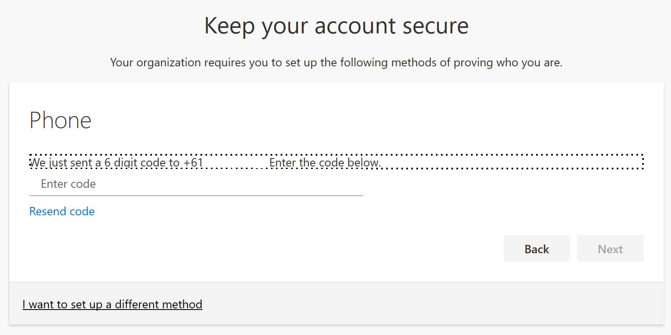

Step 4
They then enter the code on their mobile:
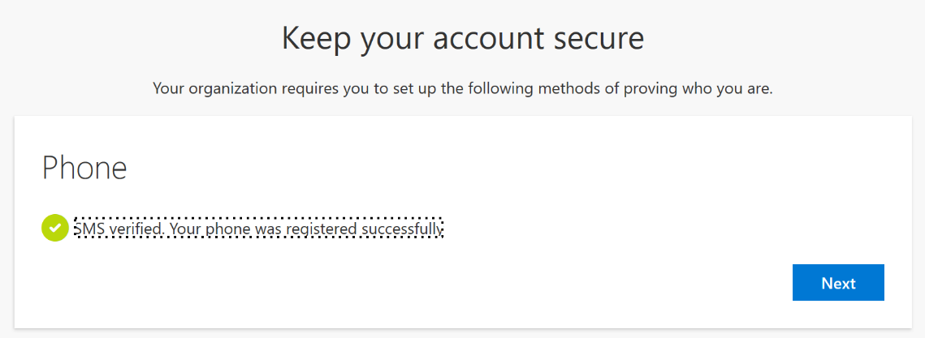

Step 5
Click ‘Next’:
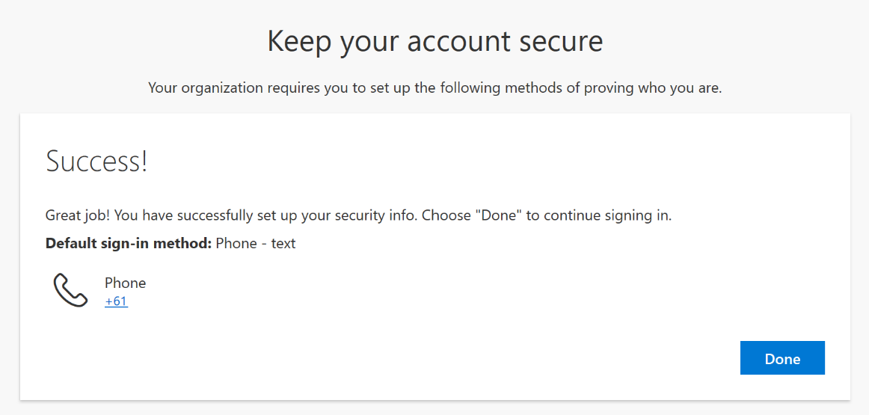

Step 6
Click ‘Done’ and success you have finally got your Team.
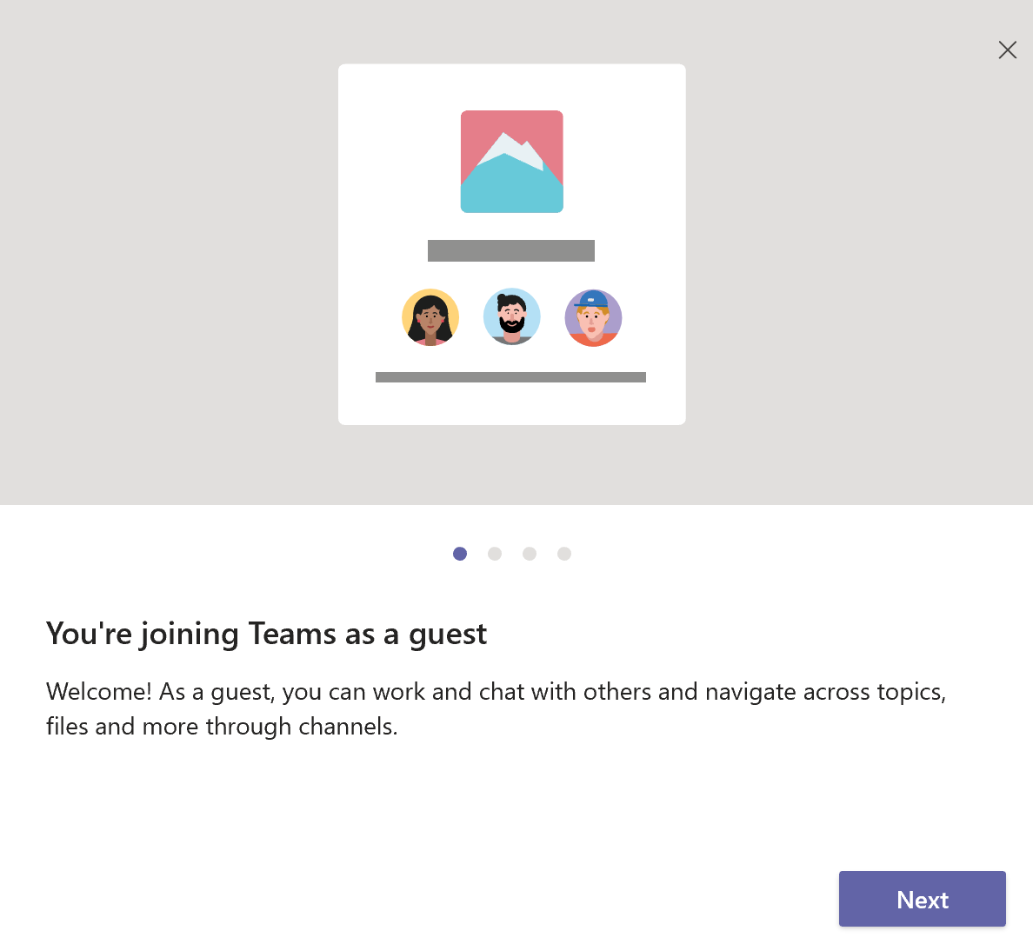

Using Microsoft Authenticator

Step 1
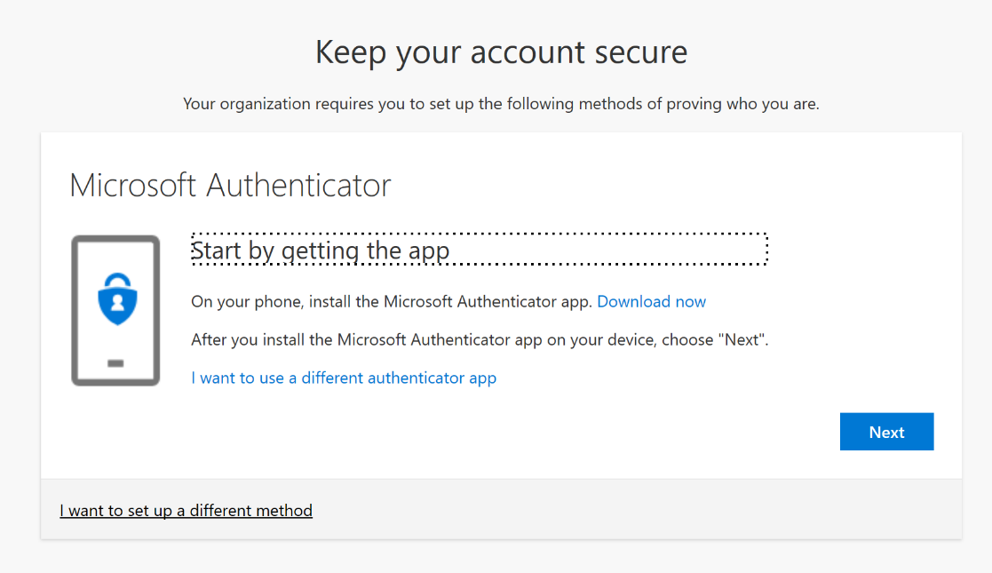

Step 2
Download the application from your mobile store and you should see a screen like this on your phone:
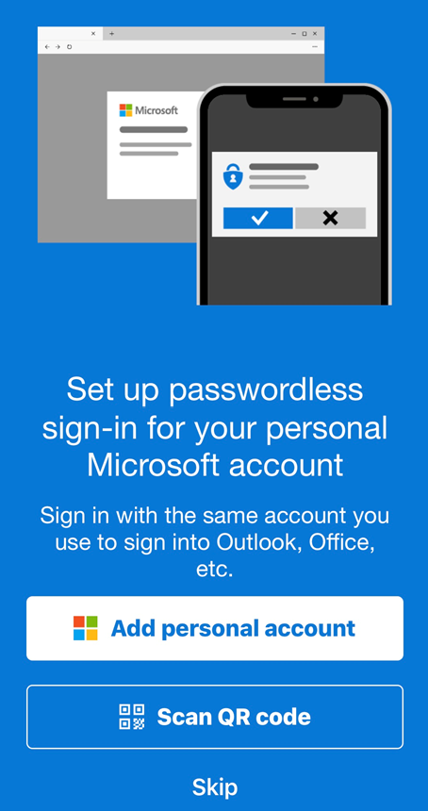

Step 3
Click ‘Next’ back on the desktop
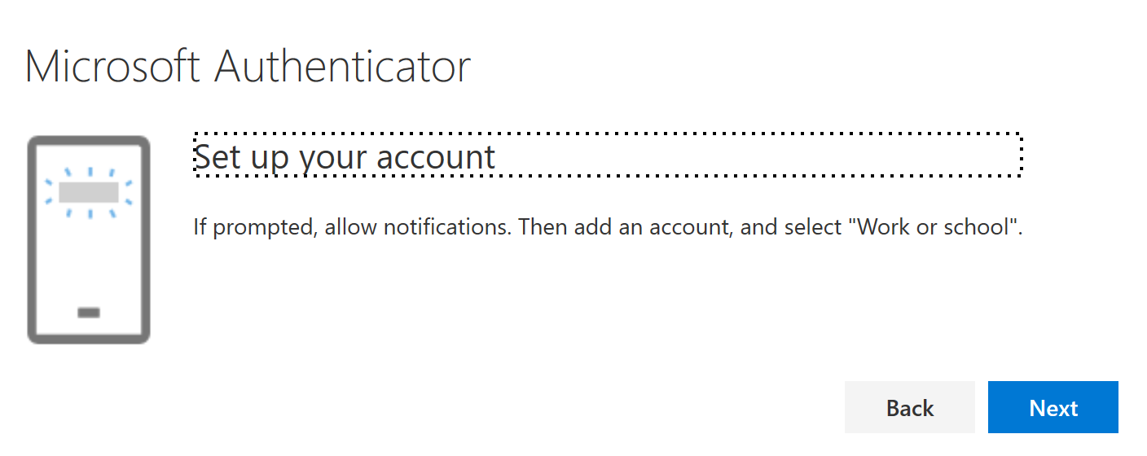

Step 4
Scan the QR code by selecting ‘Work or School Microsoft Account’ on your phone (notifications need to be on also) and select the HPW account.
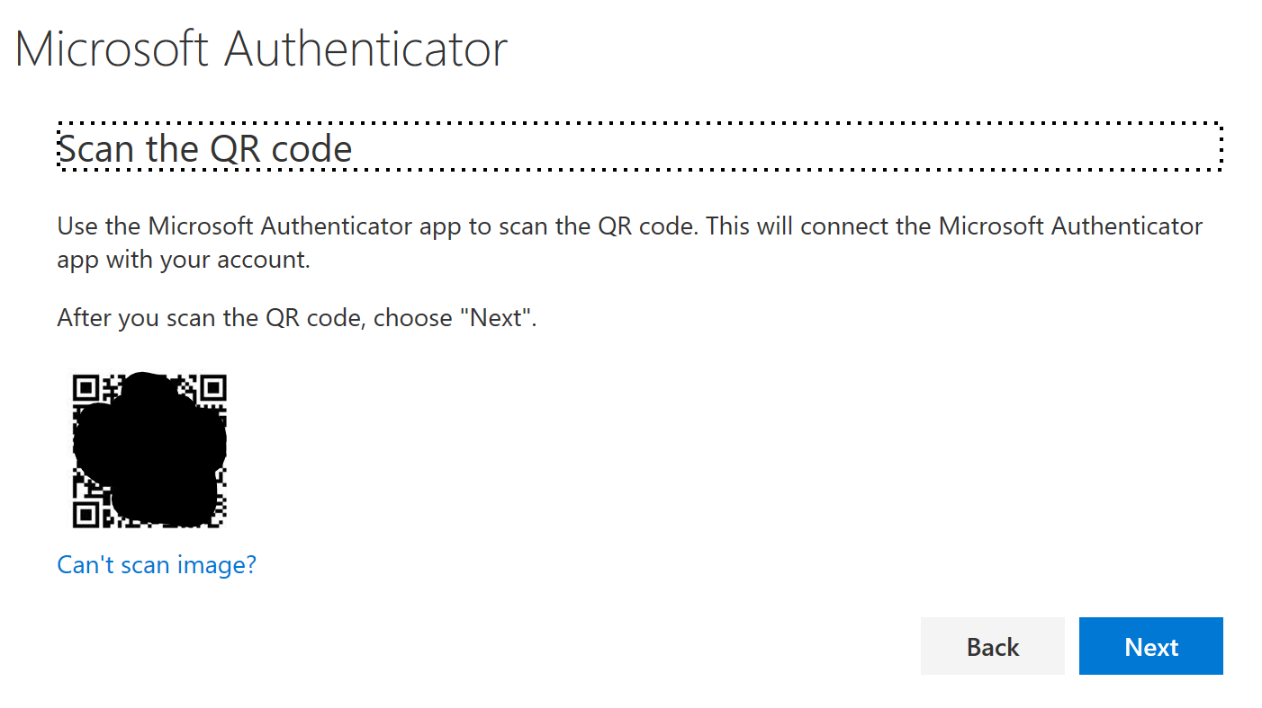

Step 5
Click ‘Next’ in the desktop browser:
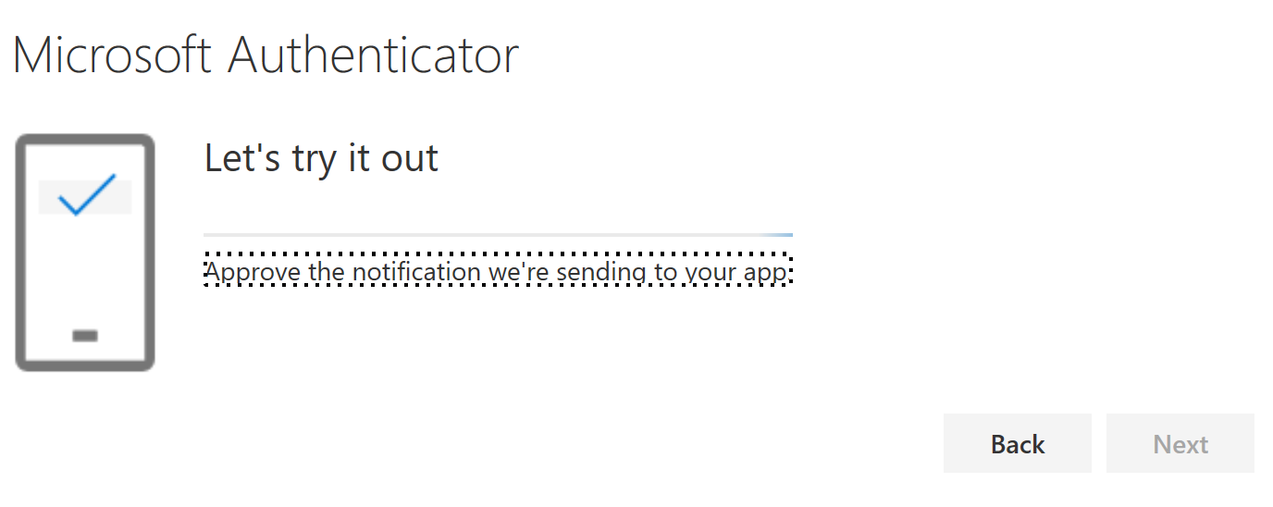

Step 6
Click ‘Next’ and ‘Approve’ on your mobile phone.

Step 7
Confirmation this worked the external user will see this screen:
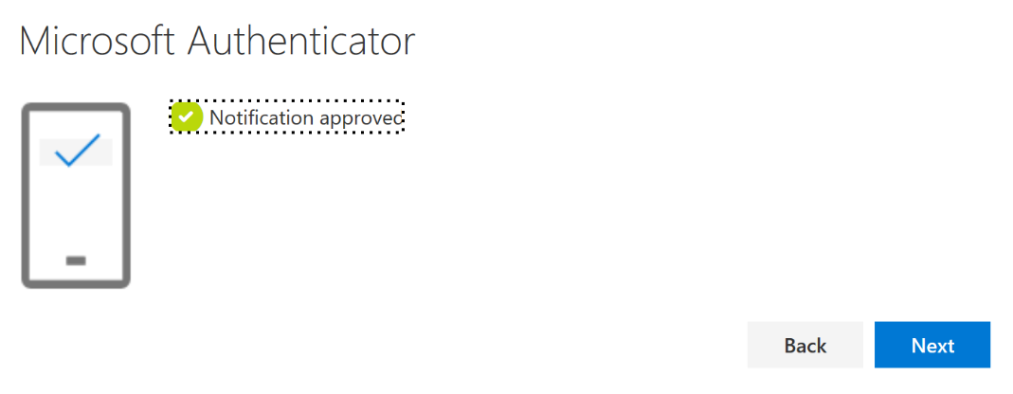

Step 8
And then this screen on your desktop:
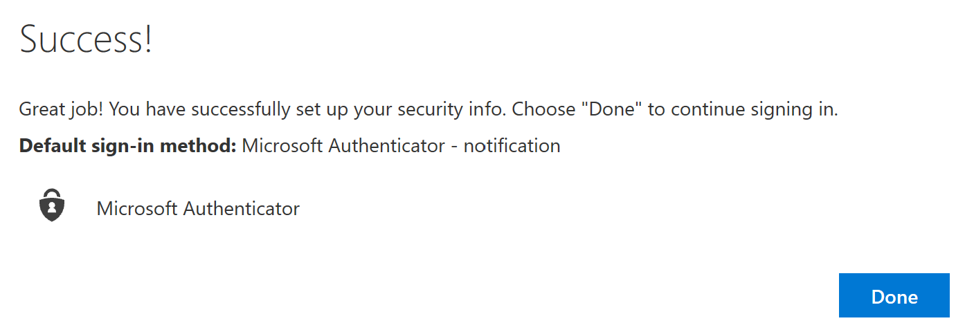

Step 9
Click ‘Done’ to finally get access to your Team.

